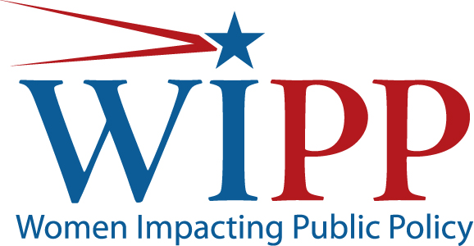

Senate Committee on Small Business and Entrepreneurship
Small Business Tax Reform: Making the Tax Code Work for Entrepreneurs and Startups
July 17, 2013
Ann Sullivan
on behalf of Women Impacting Public Policy
Thank you Chair Landrieu, Ranking Member Risch and Members of the Committee for the opportunity to be a part of this important roundtable.
Taxes are at the very core of our business and personal finances—we pay them individually, we pay them as employers, and we pay them as corporations. But among these communities of taxpayers, there is one group that, far and away, faces the toughest burden in both paying and filing taxes—America’s small businesses.
As Congress begins the process of reshaping the tax code, it provides an opportunity to address the changing shape of business and adapting the tax code to the way businesses in this country are formed and operated. Entrepreneurs now have access to world markets due to technology. They no longer need to have employees housed in a central location—they have the ability to work with contractors and employees all over the world. While some companies will seek to grow rapidly, there are many others who are content working as sole proprietors. Some businesses are full time but many provide supplemental income as part time businesses. Many entrepreneurs work out of shared spaces and their homes—no longer the traditional model that the tax code is built around. In fact, there are close to 17 million workers who are considered members of the independent workforce and their average income is $61,000. According to that research, by 2017, 23 million workers in this country will belong to this group, many of whom will be women.
As the face of business is changing, so should government entrepreneurial assistance programs. The same is true for the tax code. We see two overriding principles with respect to the rewrite: (1) is it simple? and (2) is it fair?
Small businesses spend 67% more on compliance costs than do their larger counterparts. The tax code is so complex that in order to take advantage of the deductions and credits for small businesses, a business needs to spend a considerable amount of money to take advantage of the 20 or so deductions available to them. We believe that many small businesses leave many of the current tax breaks on the table because they simply do not understand them. Therefore, our first principle is to keep it simple. It is our sense that many women-owned businesses would prefer a lower tax rate in exchange for the current system of deductions and credits.
In fact, when WIPP members were asked, as a part of the 2013 annual survey, if they would support lowering individual and corporate tax rates in exchange for fewer deductions and credits, 57% of members said that they were in support.
Our second principle with respect to tax reform is fairness. Currently, business designations come in many different forms: partnerships, S-corps, C-corps, LLCs and sole-proprietorships. We believe that any business tax deduction or credit should be applicable to any form of business, no matter how it is created. An example is the deductibility of employer contributions to employee health insurance plans that many small businesses owners claim. Unfortunately, that deduction is not available for the self-employed. In our view, business is business.
One Time Tax Incentive for New Businesses
The Senate Finance Committee has stated that the tax code should effectively promote important policy objectives. In that vein, it seems to us that giving a one time incentive to individuals to start businesses could remove a barrier to business creation. It would have to be simple, but could be an effective tool to launch new businesses.
Encourage Investment in Small Business
Tax incentives could be used to stimulate investment in small businesses. A number of them exist in today’s tax code. We believe a tax break to angel investors, among others, could serve as a catalyst to spur investments under $5 million. We note that Louisiana has such an incentive already in place.
Rewarding Employee Ownership
Businesses with employees who are financially invested in the company’s success often produce impressive results. For example, the Employee Stock Ownership Plan (ESOPs) has been a particularly noteworthy incentive. ESOPs have been a valuable option for employees to be rewarded for hard work and to move on after the departure of an owner. Even more important, they represent another way for small businesses to raise capital. These plans should carry protections to prevent undue risk to employees, but have demonstrated an increase in production and profitability of many small businesses.

The State of Independence In America, Emergent Research, September 2012: http://www.mbopartners.com/state-of independence/docs/2012MBO_Partners_State_of_Independence_Report.pdf
Office of Advocacy, U.S. Small Business Administration

